2015 May 6

Seokju Hong, Youngseok Kim

team 2

Design model

SafeHome Project

Table of Contents

1. Introduction 4

2. Use case diagram 5

2.1. SafeHome bootup/shutdown service 5

2.2. Configuration service 6

2.2.1. Password registration 6

2.2.2. Password registration (web) 7

2.2.3. Grouping devices 8

2.2.4. Web session timeout 9

2.3. Real time security service 10

2.3.1. Arming-disarming devices and system 10

2.3.2. Setting travel mode 11

2.3.3. SafeHome security system(sensor and camera actuator part) 12

2.4. User-requested information retrieval service 13

2.4.1. Retrieve ID and PW 13

2.4.2. Report system usage pattern 14

2.4.3. Report web page access history 15

3. Use cases 16

3.1. SafeHome bootup/shutdown service 16

3.1.1. SafeHome bootup 16

3.1.2. Sensor check 17

3.1.3. Camera check 18

3.1.4. Shutdown 19

3.2. SafeHome configuration service 20

3.2.1. Password registration – Control panel 20

3.2.2. Password registration – Web 21

3.2.3. Grouping devices 22

3.2.4. Web session timeout 23

3.3. SafeHome real-time security service 24

3.3.1. Arm-system 24

3.3.2. Arm-device 25

3.3.3. Disarm-system 26

3.3.4. Disarm-device 27

3.3.5. Alarm-house 28

3.3.6. Alarm-user 29

3.3.7. Alarm-emergency-agent 30

3.3.8. Set travel mode 31

3.3.9. Detect motion 32

3.3.10. Detect window action 33

3.3.11. Detect high gas concentration 34

3.3.12. Fire detection 35

3.3.13. Detect dog barking 36

3.3.14. Camera view 37

3.3.15. Camera record 38

3.3.16. Retrieve CCTV data 39

3.3.17. Camera zoom 40

3.3.18. Camera pan 41

3.4. User-requested information retrieval service 42

3.4.1. Finding ID/Password 42

3.4.2. Reporting system usage pattern 43

3.4.3. Reporting web page access history 44

4. Swimlane diagram 45

4.1. SafeHome bootup/shutdown system 45

4.1.1. SafeHome bootup 45

4.1.2. SafeHome shutdown 46

4.2. Configuration service 47

4.2.1. Password registration 47

4.2.2. Password registration (web control panel) 48

4.2.3. Grouping devices 49

4.2.4. Web session timeout 50

4.3. SafeHome real-time security service 51

# Introduction

* 1. Document introduction

This document is a SafeHome project Phase 3 which contains design model for the SafeHome product. This document contains sequence diagrams, class diagrams, and state diagrams. This document is written by Young Seok Kim and Seokju Hong. Since the scope of the project has been changed, revision of the software requirement specification and analysis model was inevitable, so the authors had to revise the software requirement specification document and analysis model document in order to write this design model document. This document is written for the developers as well as professor, TAs and other students. This document is based on the revised software requirement specification document and “Sample SRS overview” document from the professor. All of the diagrams in this document is drawn with StarUML software with limited evaluation license.

* 1. Assumptions

Only one user can configure the SafeHome system simultaneously.

(Concurrent access to the SafeHome system is not allowed.)

There is only one control panel in the house.

Internet connection between a home owner and the SafeHome system is always available.

All devices including camera(s), sensor(s), and the SafeHome main system communicate using IEEE 802.11x protocol.

* 1. Additional note

Note that in 2.2, the login and logout feature is added. The previous document implicitly explained about the login and logout. In this design model document, these features are explicitly written because they are used frequently in other features.

# Sequence diagram

## SafeHome bootup/shutdown service

* + 1. bootup
* Related Use Case: UC1-1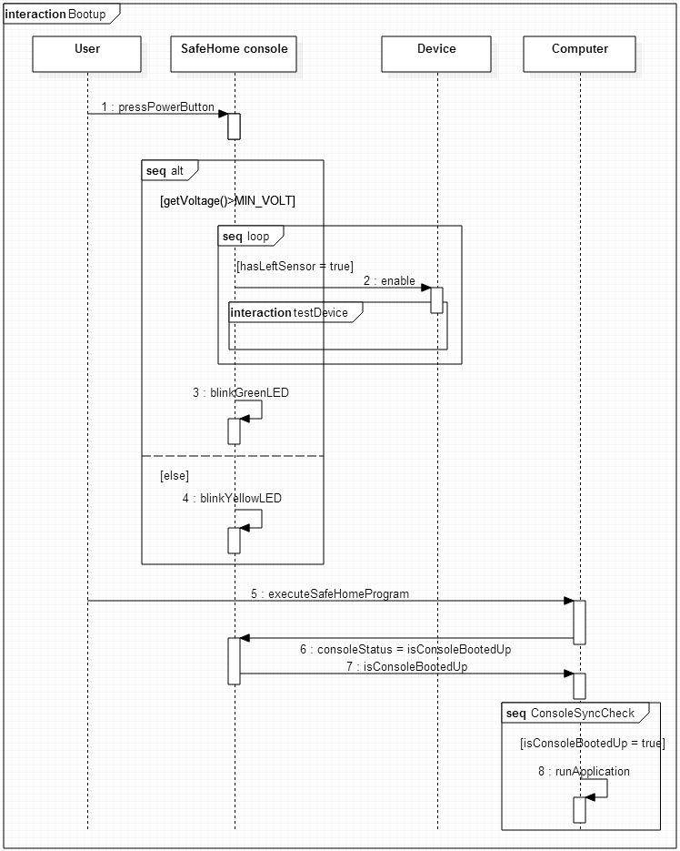
  + 1. Test device  
         
       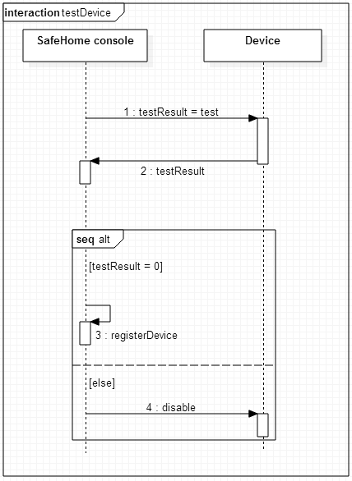
    2. 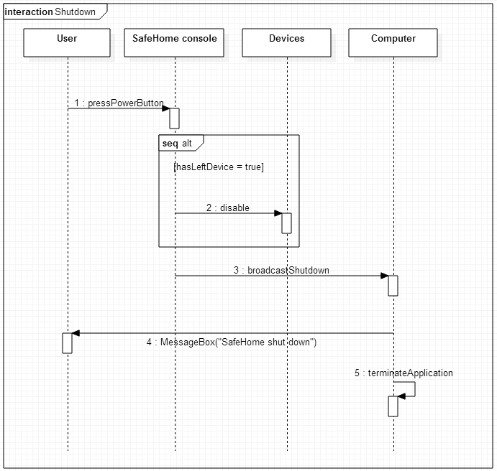shutdown

2.2 SafeHome configuration service

2.2.1. Password registration

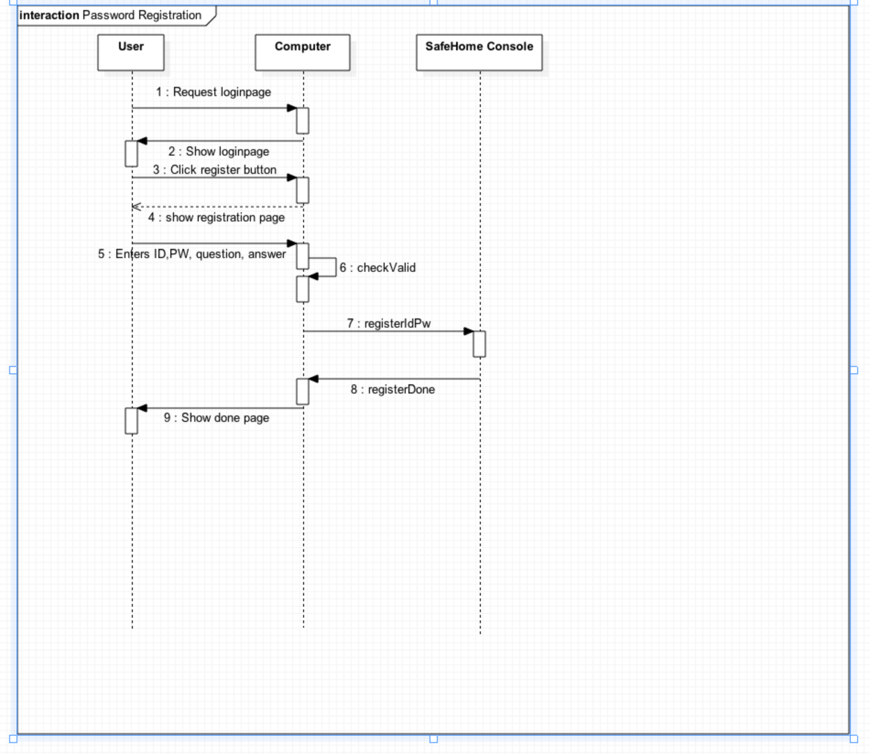

2.2.2. Configure security zone

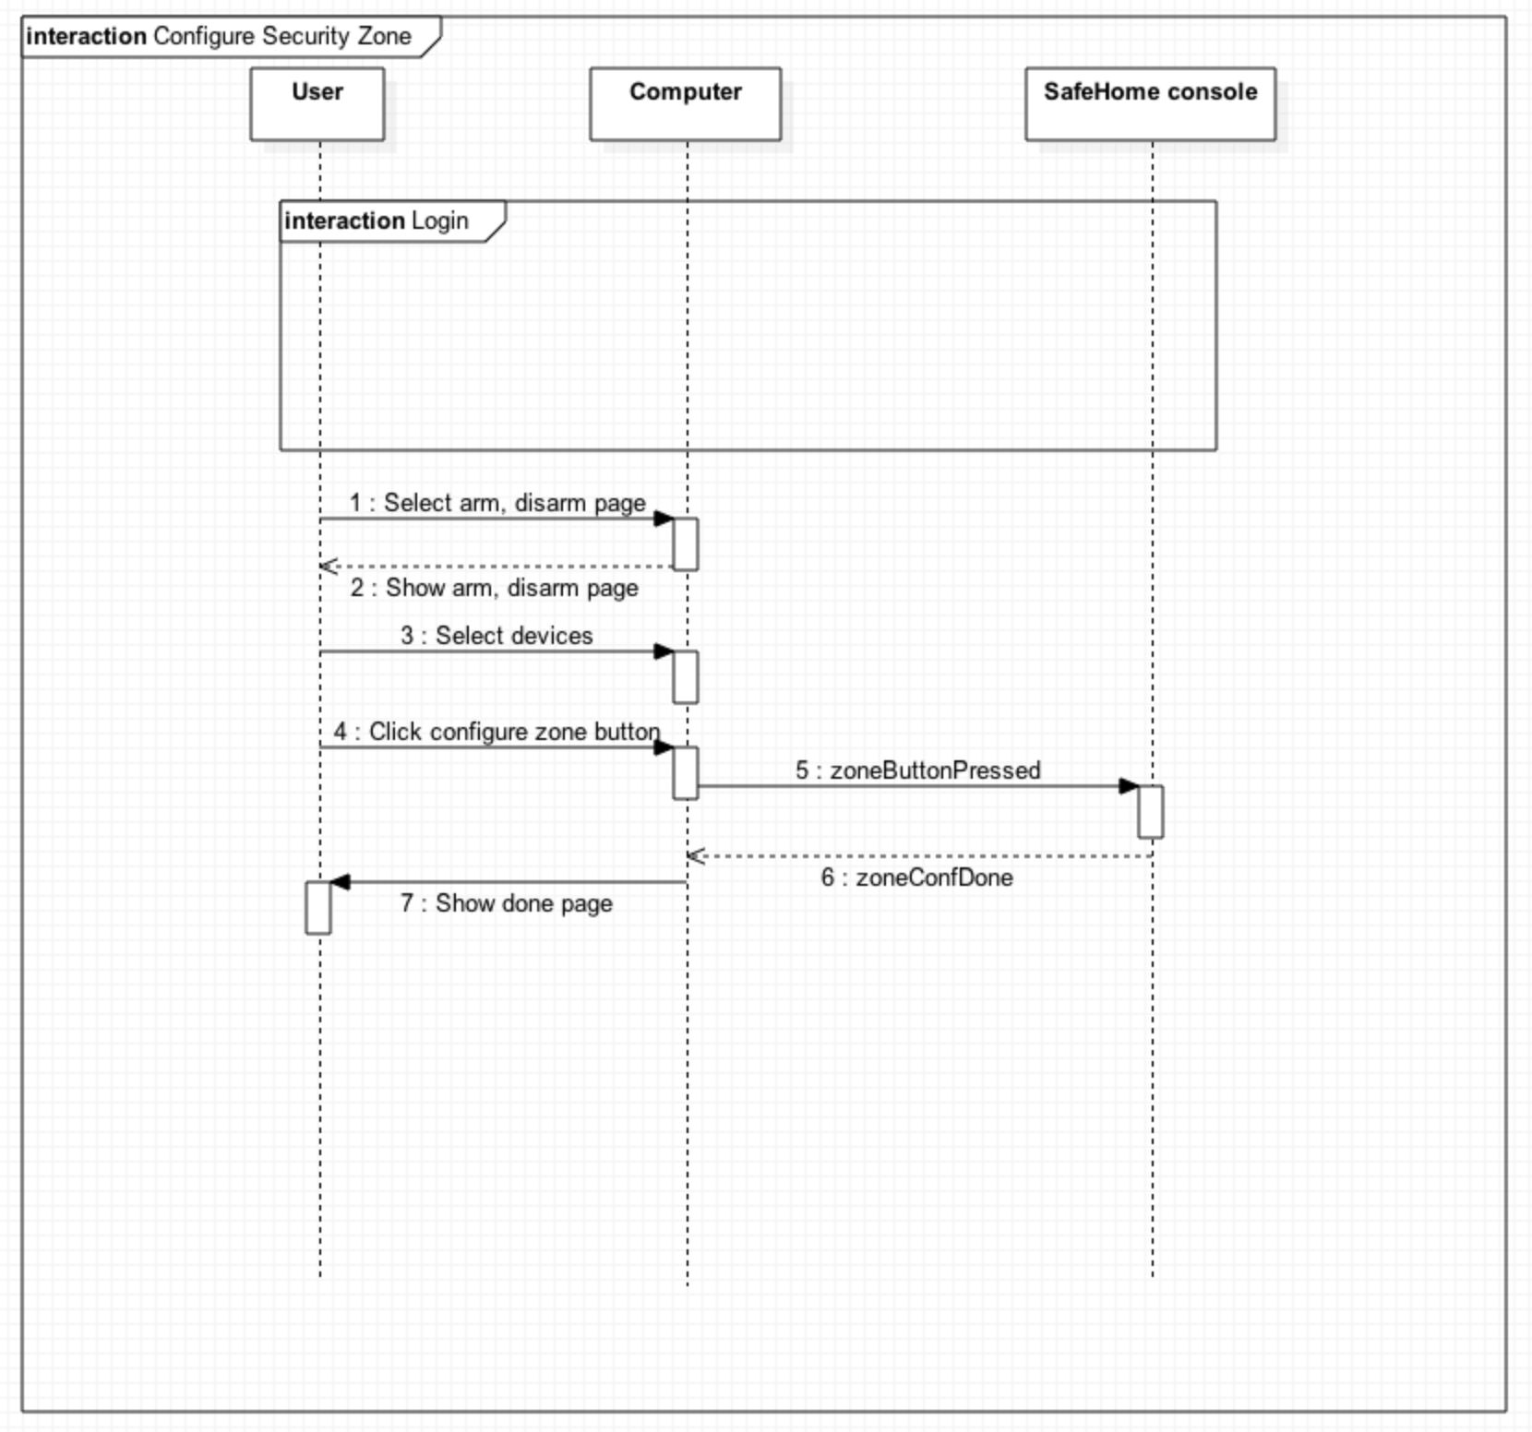

2.2.3. Session timeout

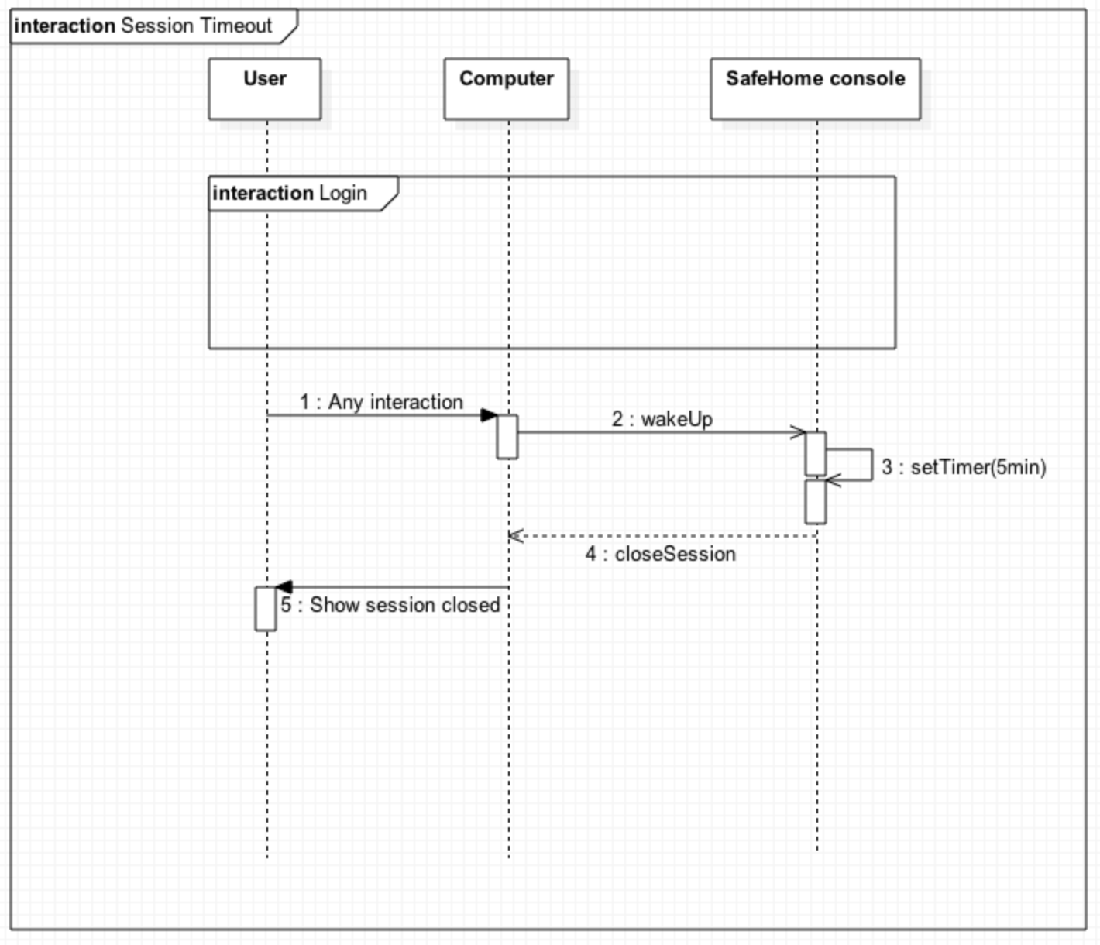

2.2.4. Login

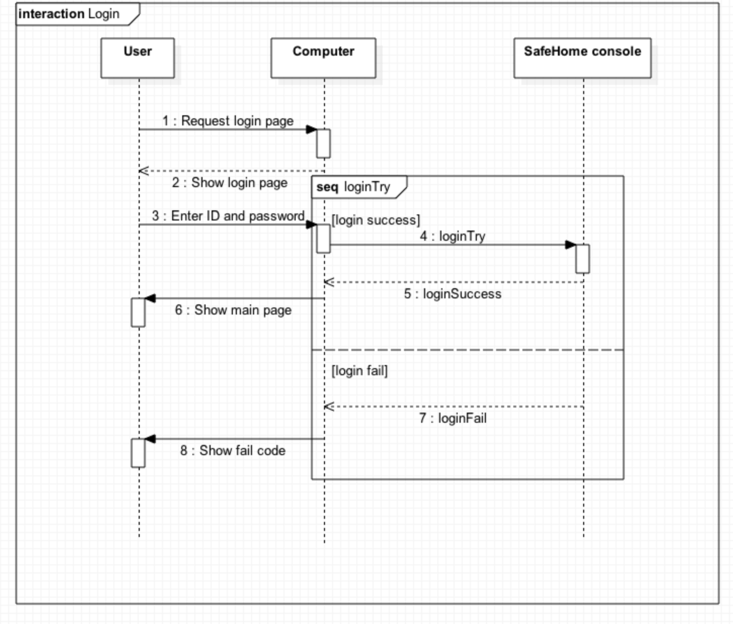

2.2.5 Logout

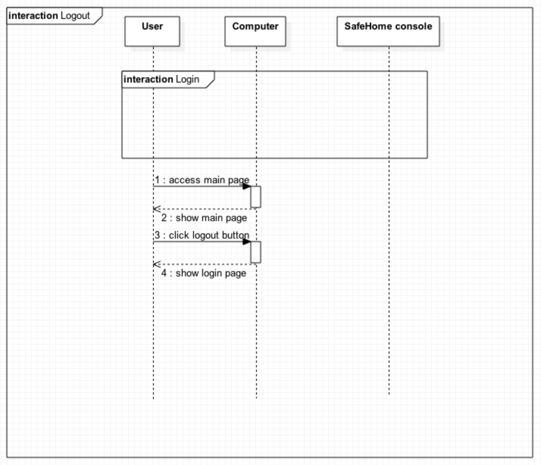

2.3. SafeHome real-time security service

2.3.1. Arm all devices

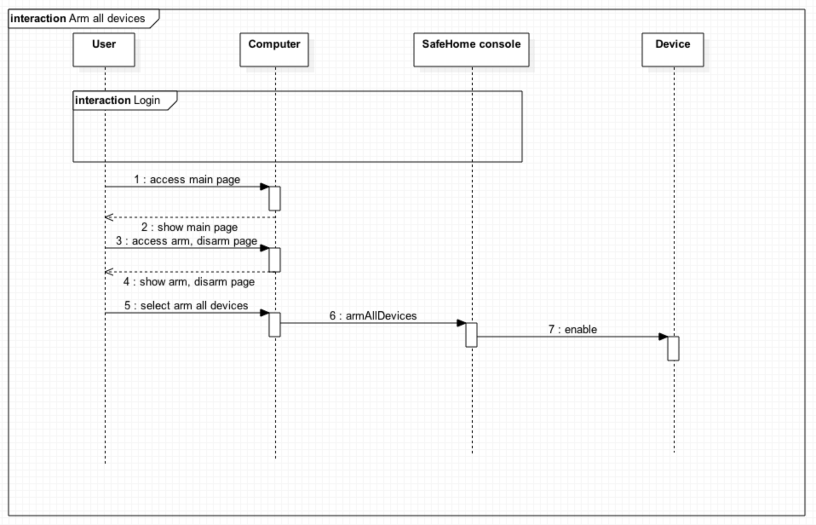

2.3.2. Disarm all devices

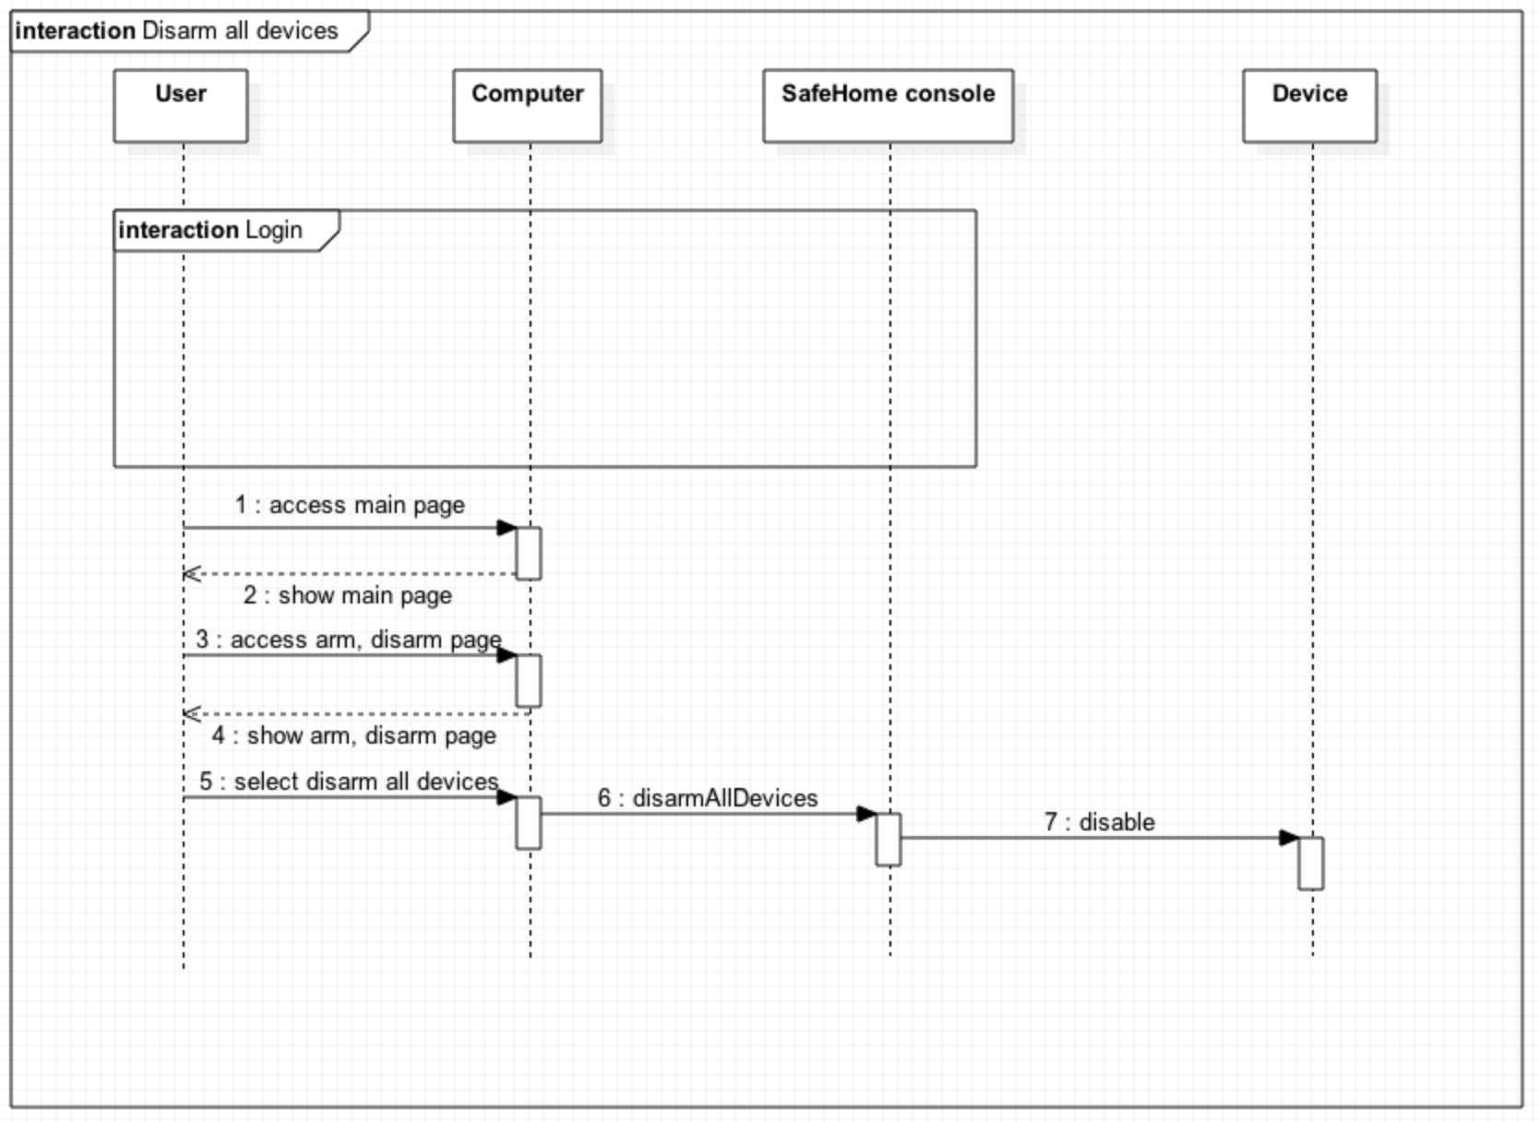

2.3.3. Arm single device

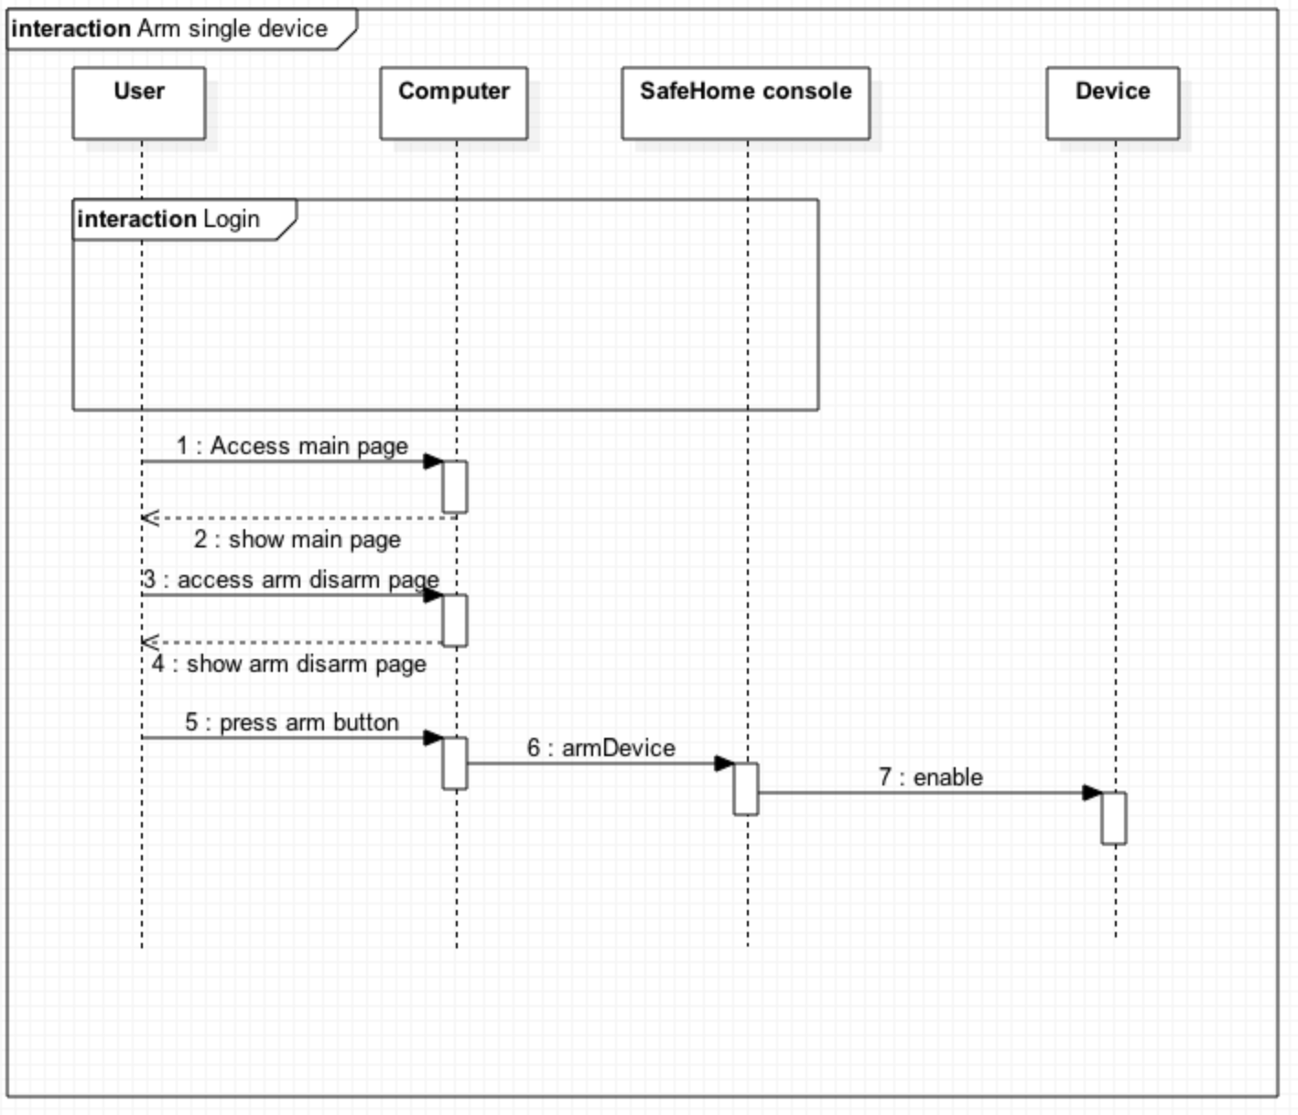

2.3.4. Disarm single device

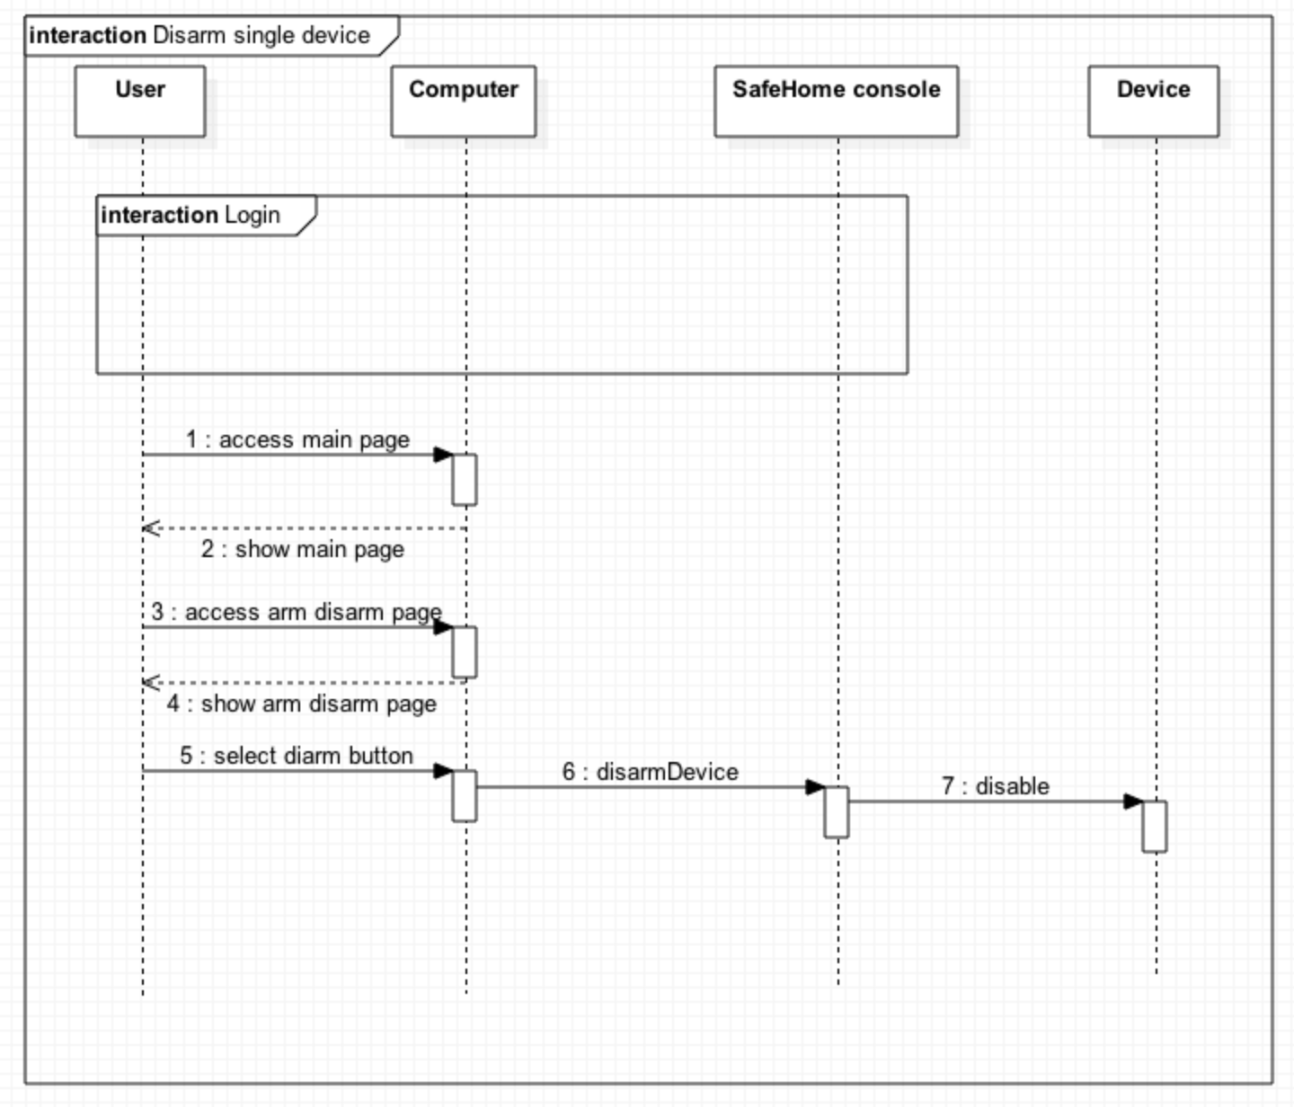

2.3.5. Alarm Home

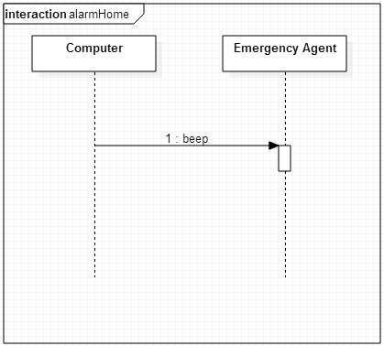

2.3.6. Alarm user

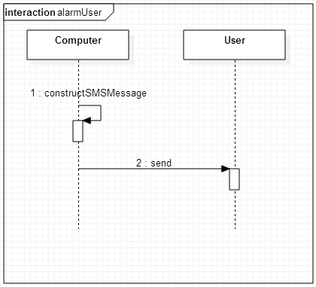

2.3.7. Alarm-emergency agent  
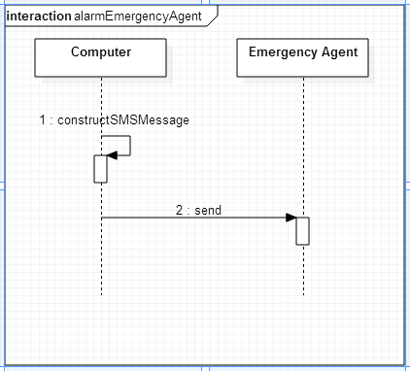

2.3.8. Set travel mode  
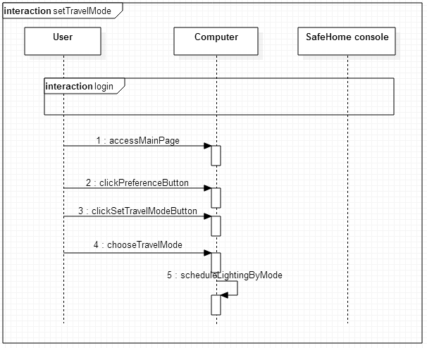

2.3.9. Lighting Heating Control

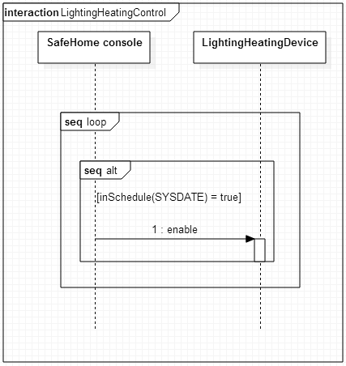

2.3.9. Detect motion

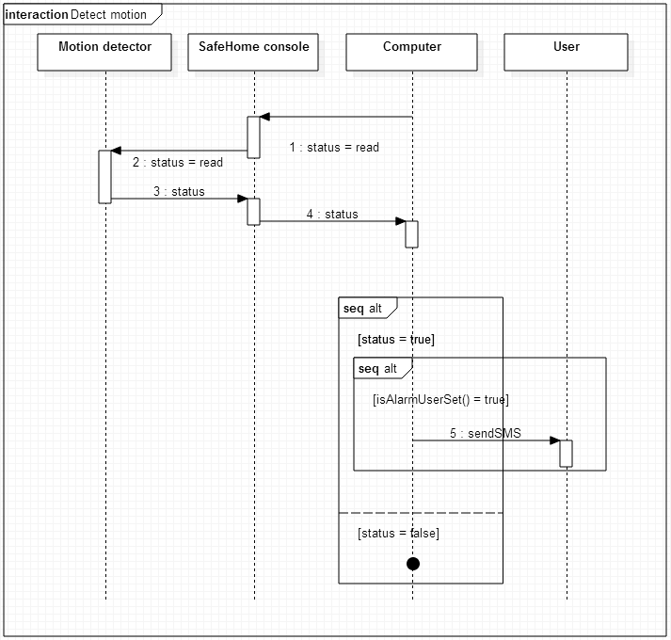

2.3.10. Detect window action  
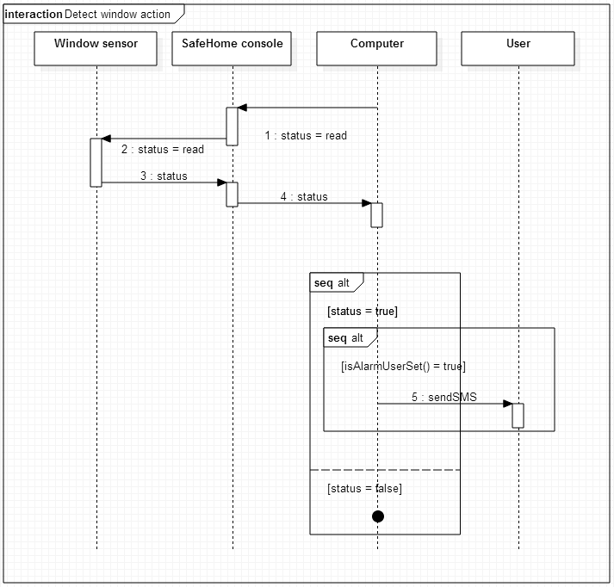

2.3.11. Detect high gas concentration  
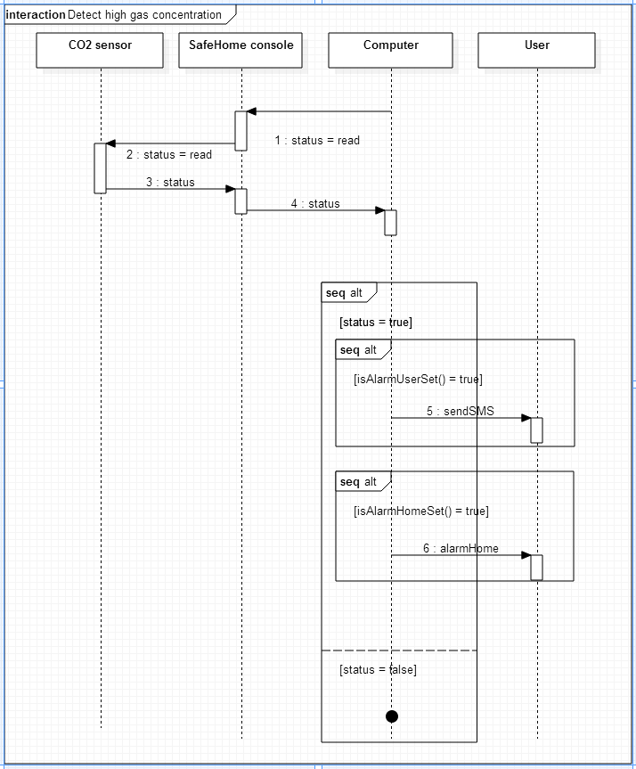

2.3.12. Fire detection

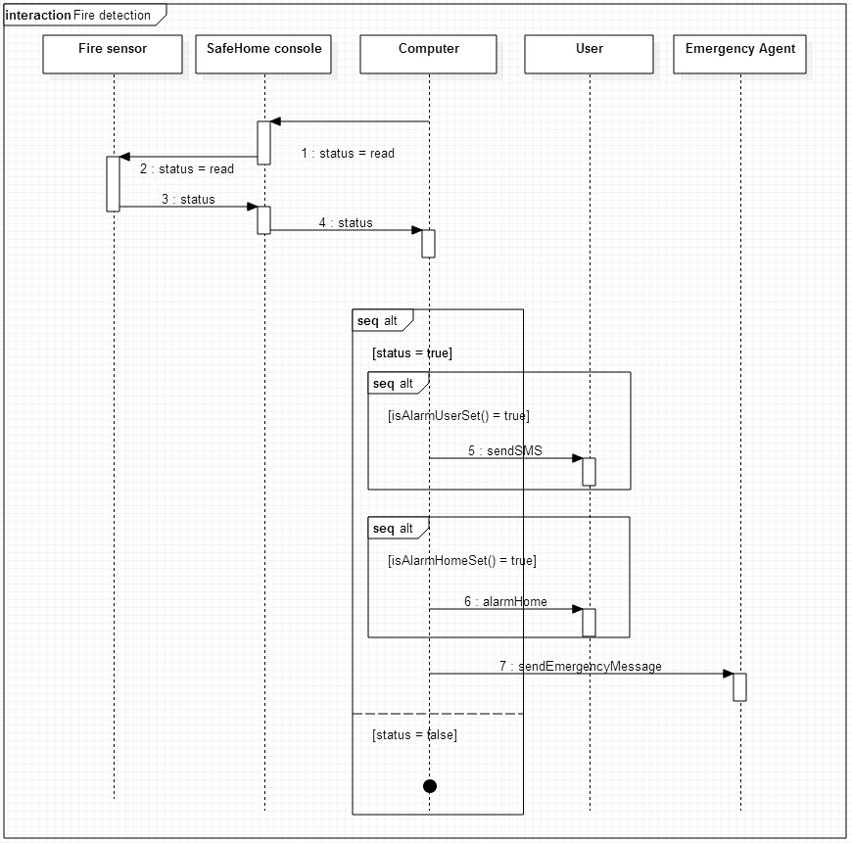

2.3.13. Detect dog barking

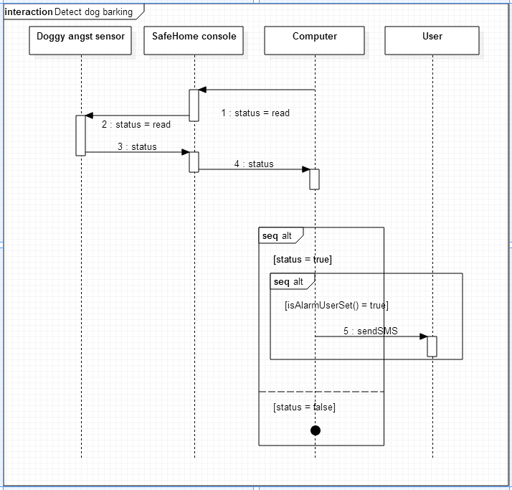

2.3.14. Camera view

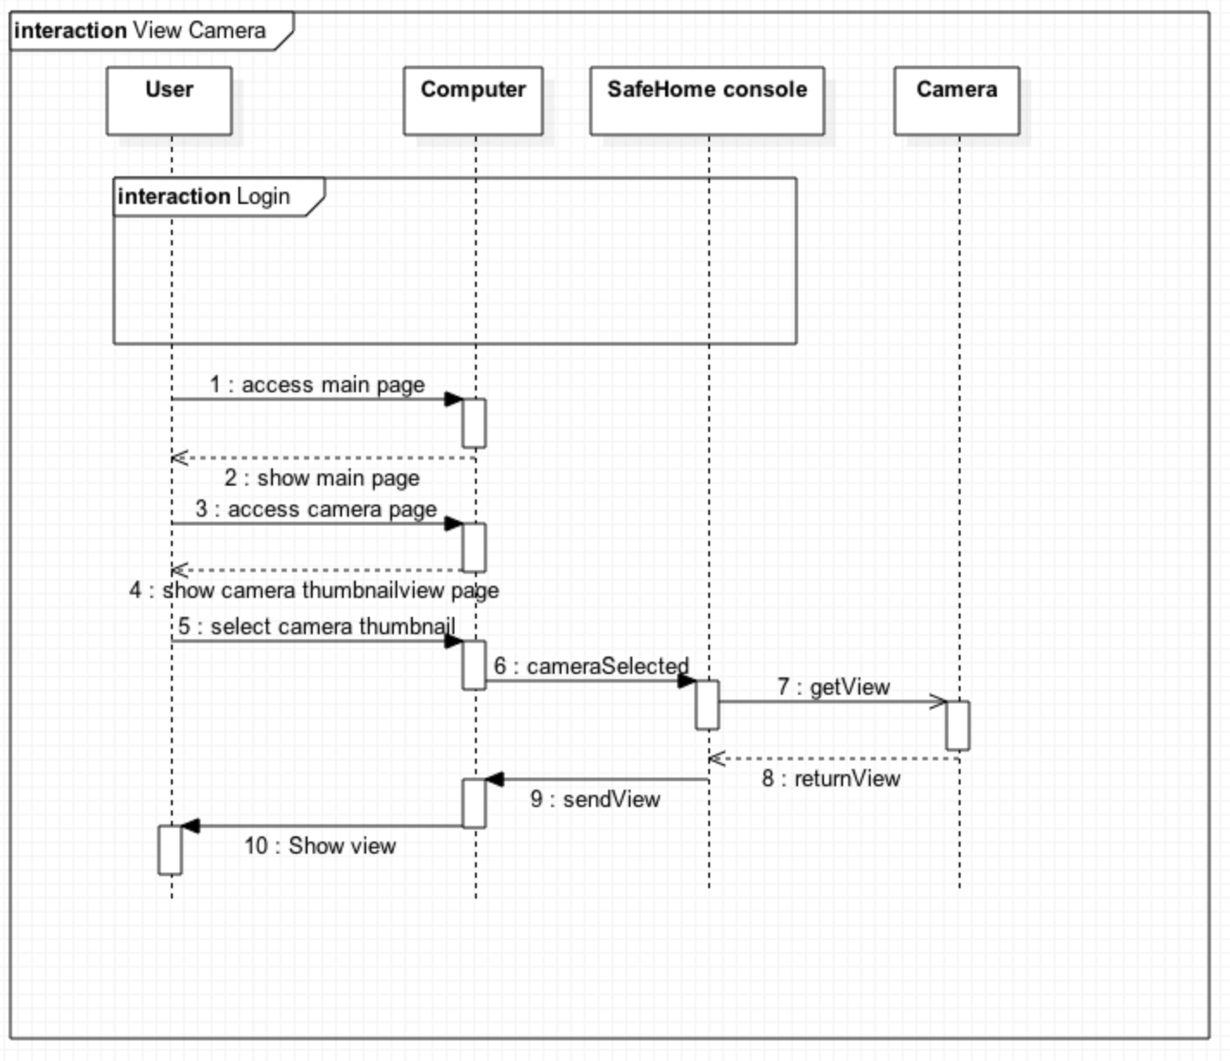

2.3.15. Record camera

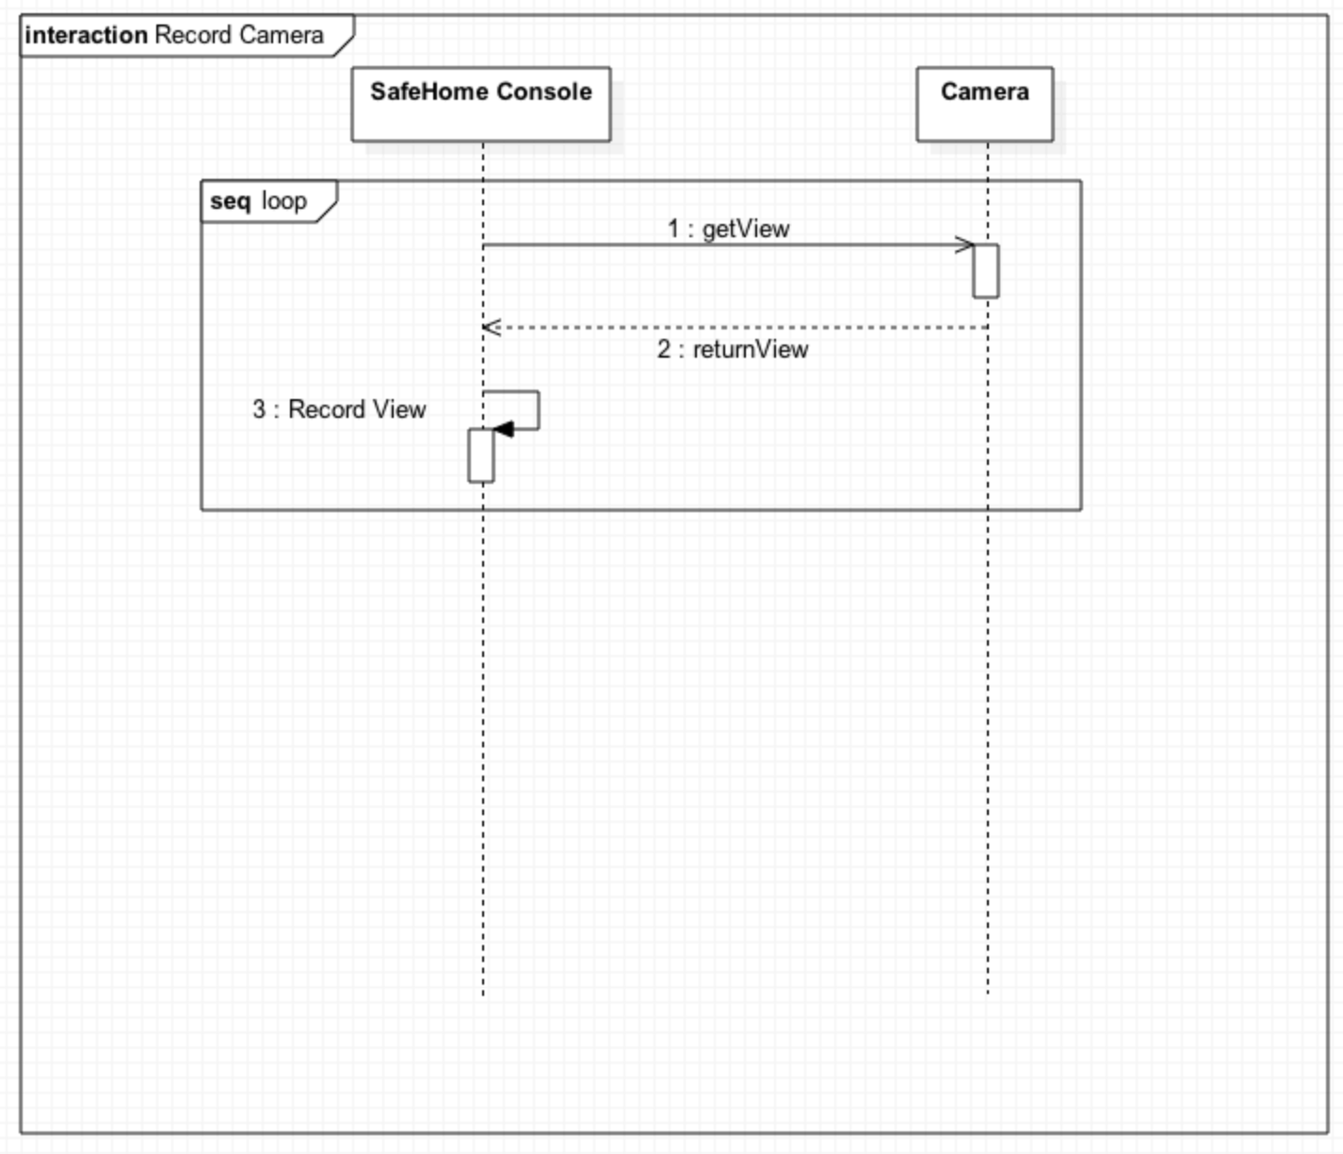

2.3.16. Camera zoom

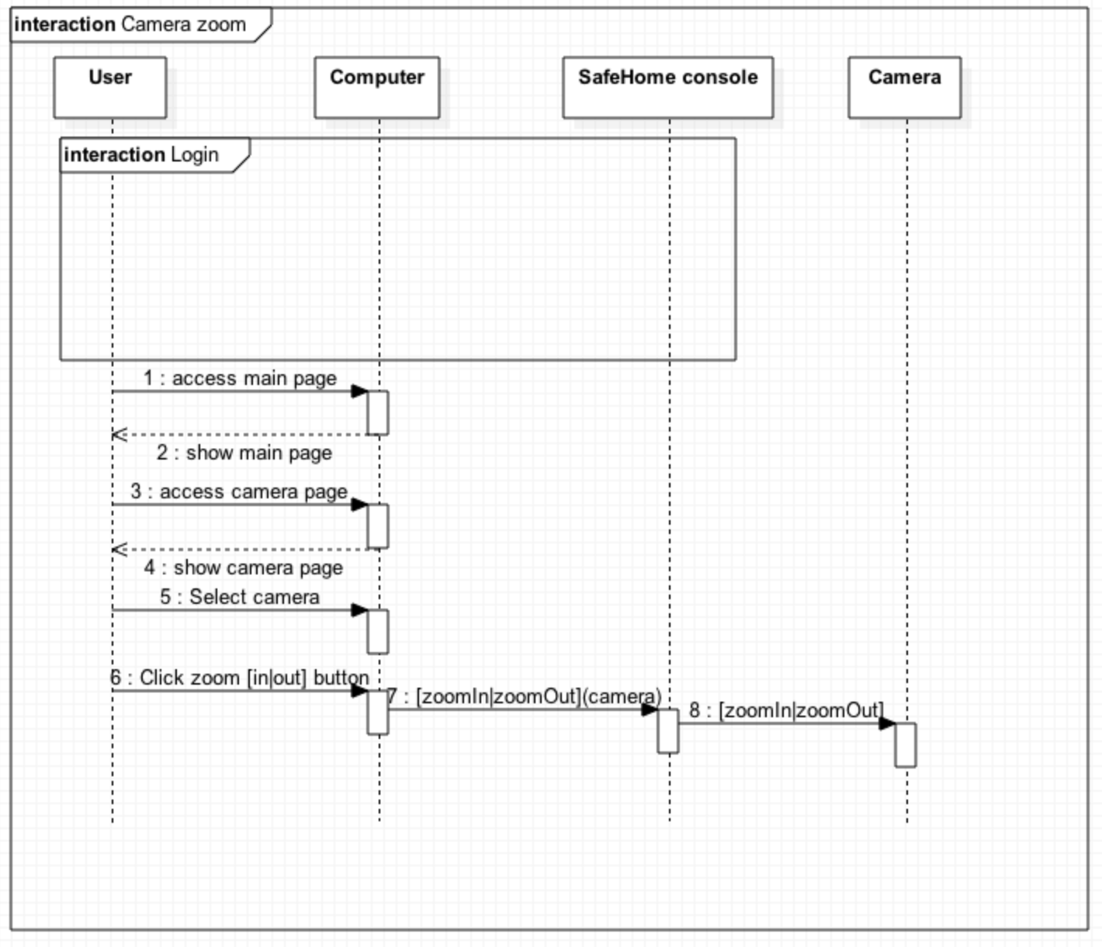

2.3.17. Camera pan

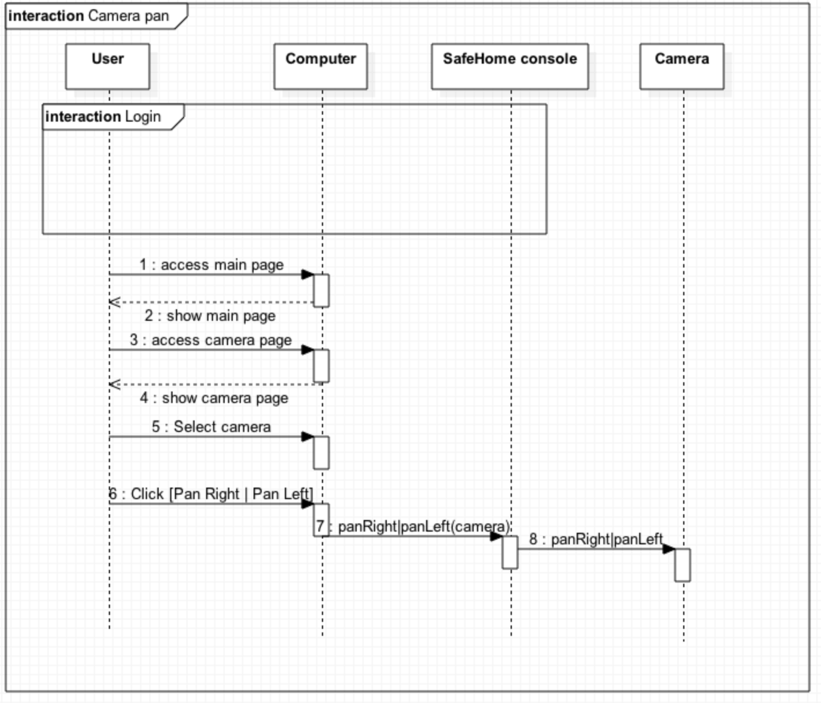

2.3.18. Replay recorded movie

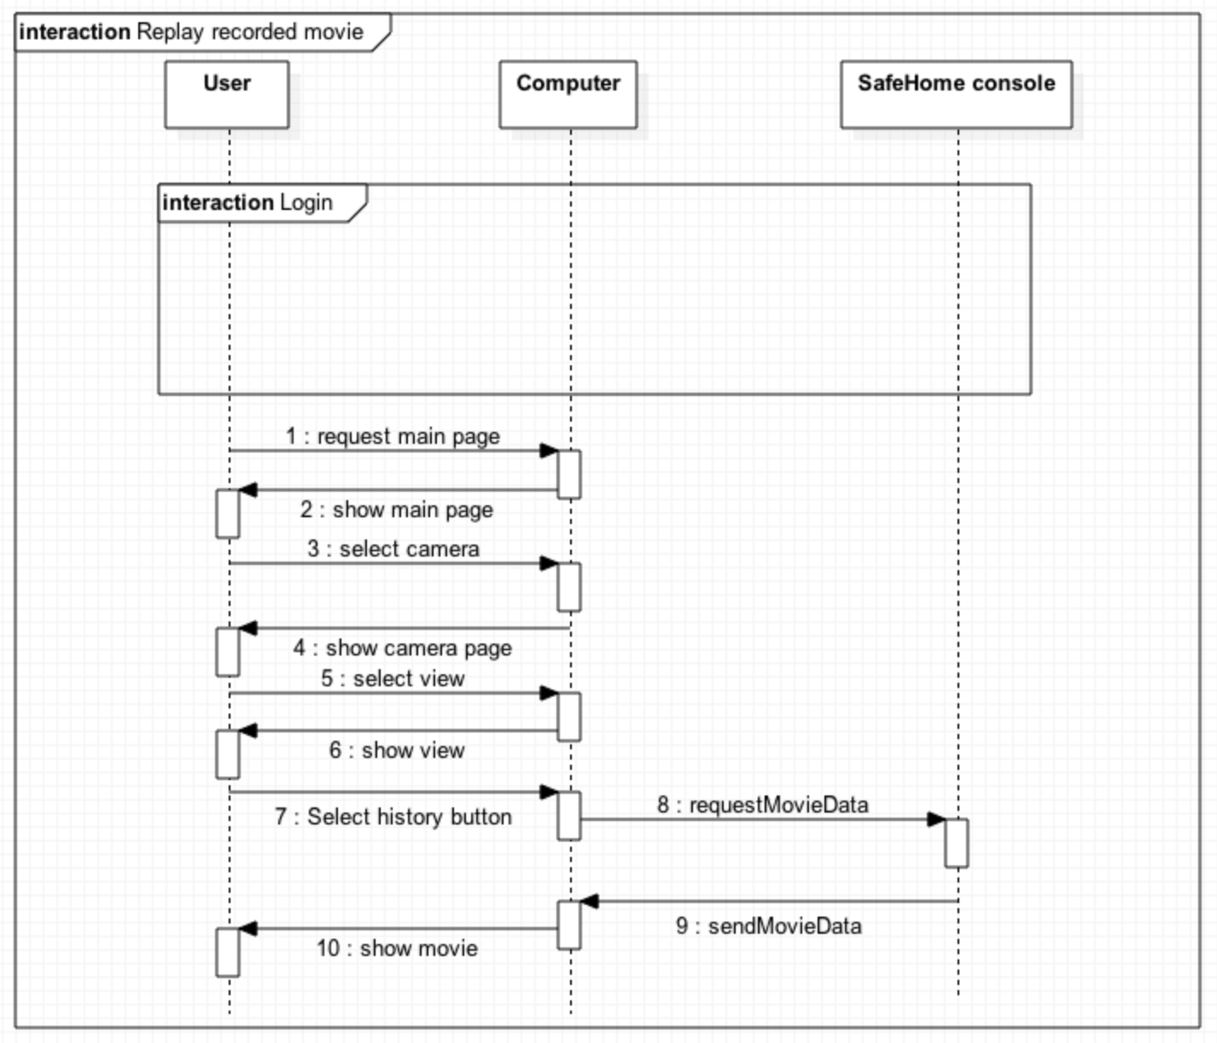

2.4. User-requested information retrieval service

2.4.1. Find ID/PW

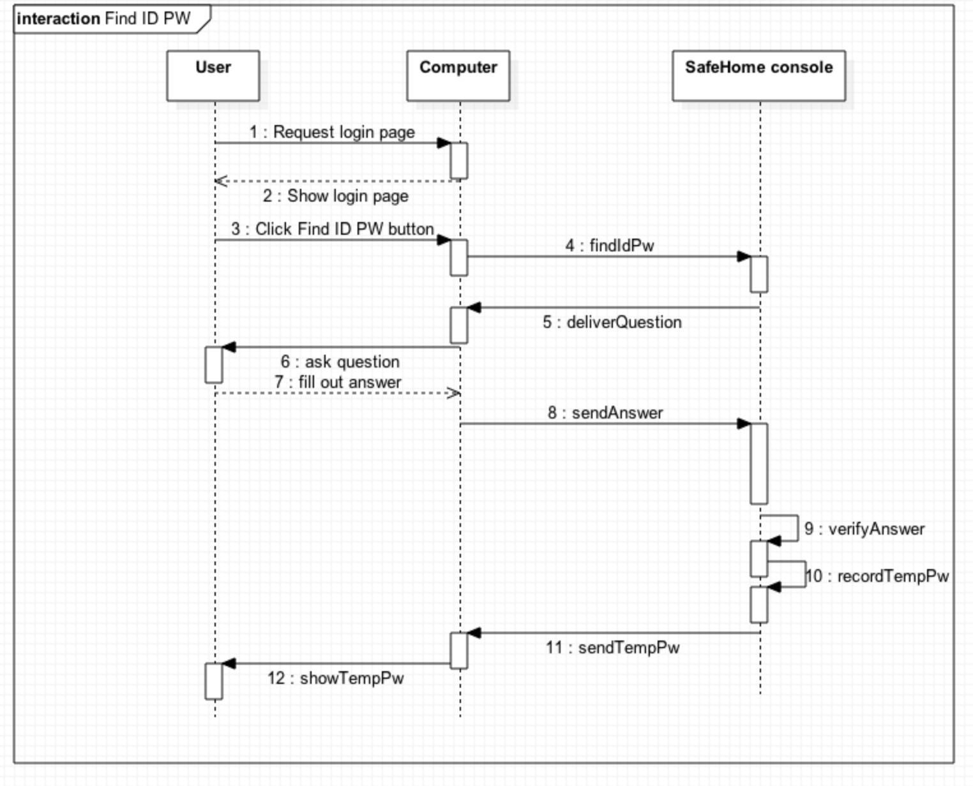

2.4.2. Report system usage pattern

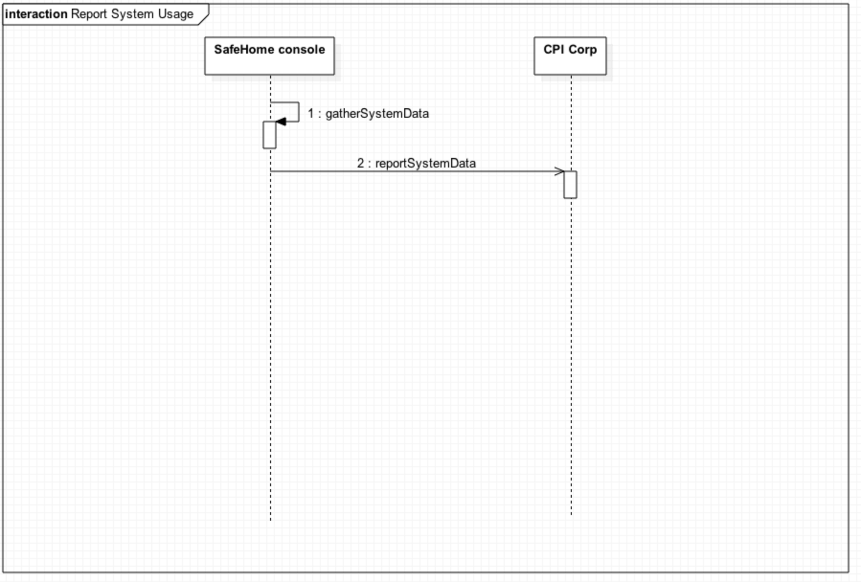

2.4.3. Report page access history

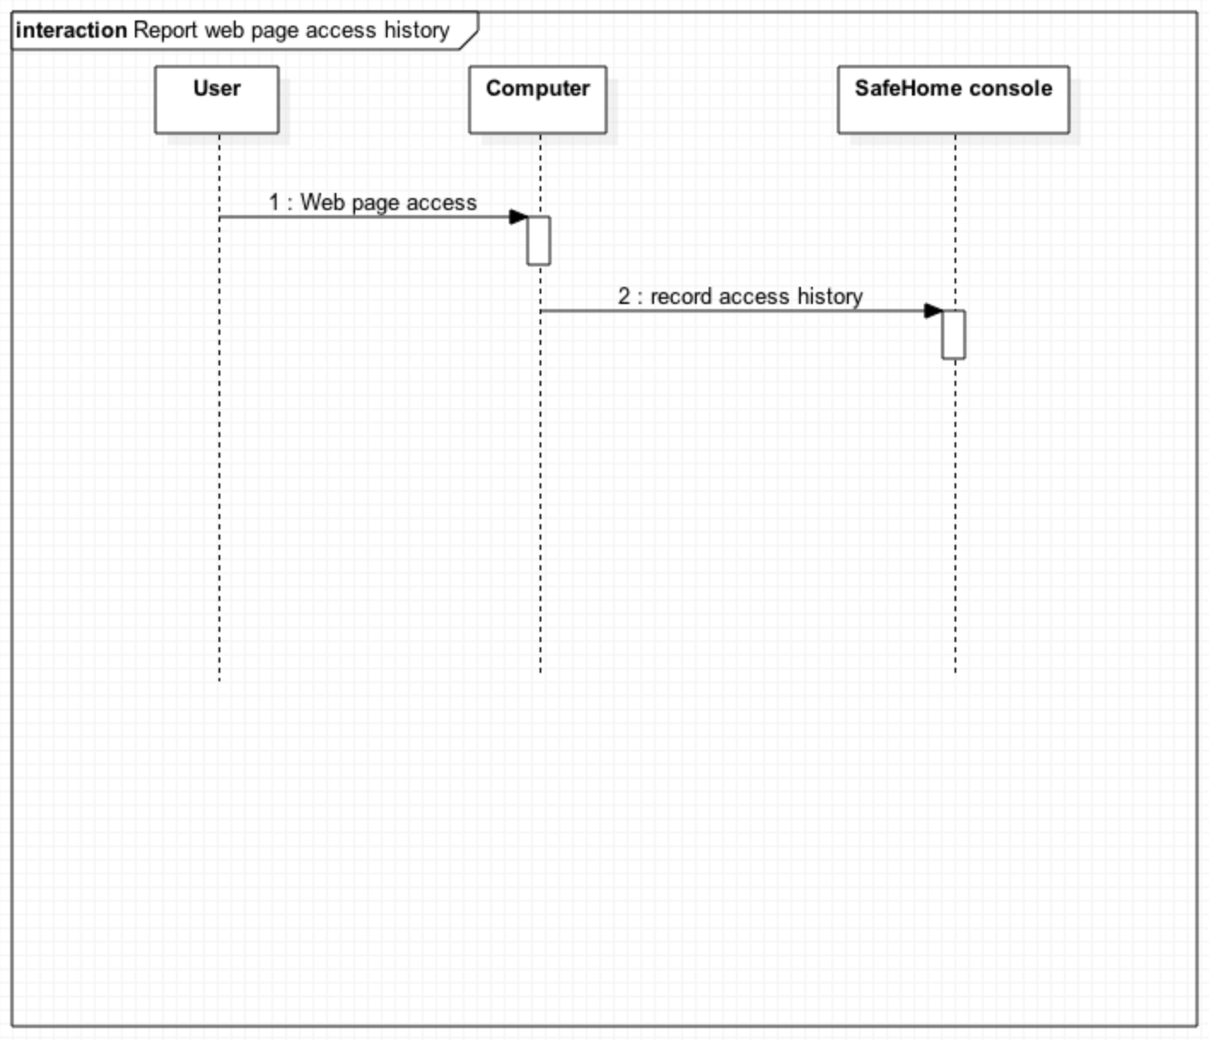

1. State diagram
   1. Main computer

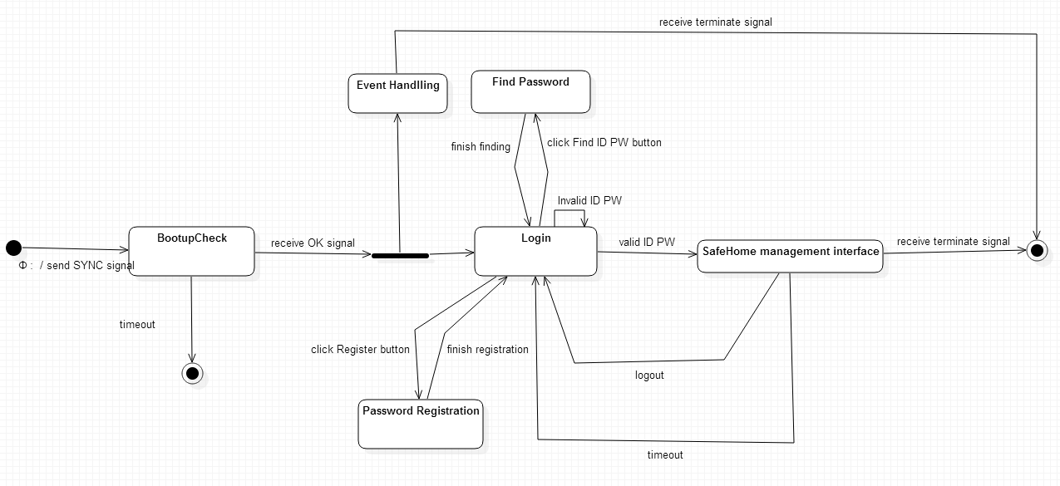

* 1. Event handling

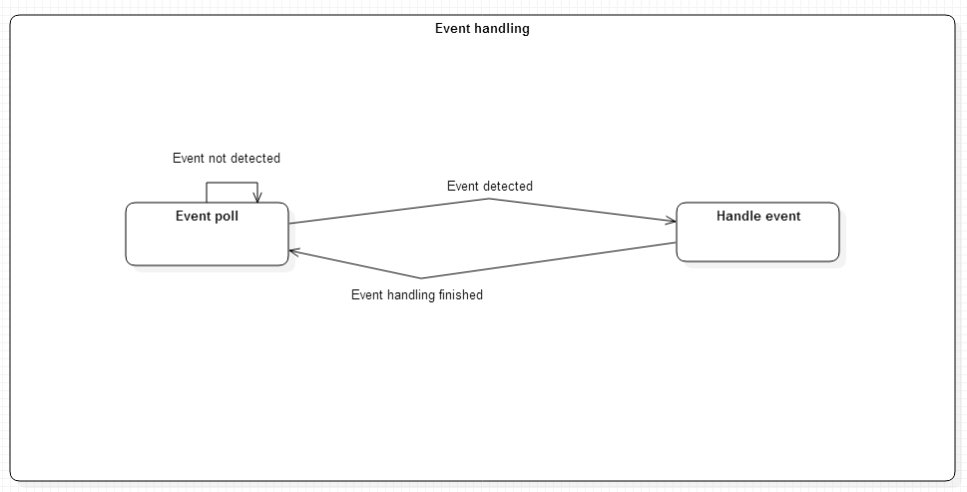

* 1. management interfaces

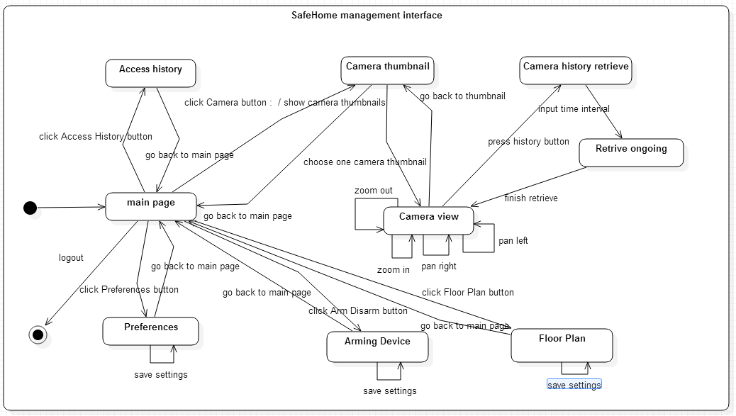

* 1. SafeHome console

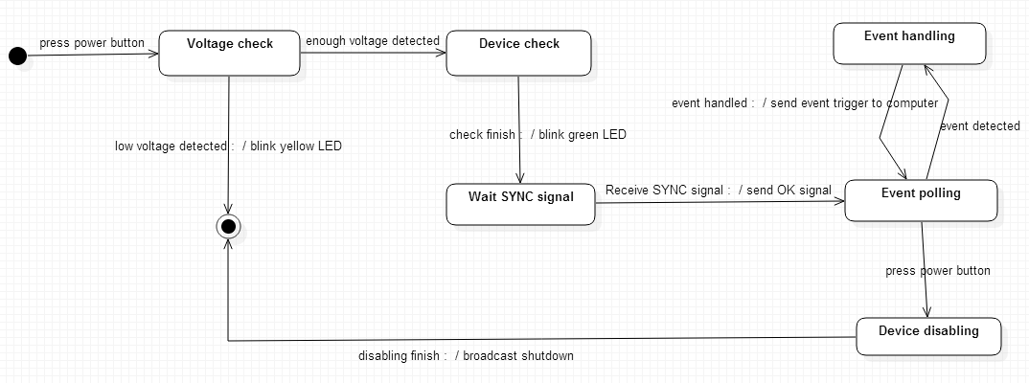

## Class diagram

### SafeHome application and

# Authorship

**1 – Introduction**

Introduction is written by Young Seok Kim

**2 – Sequence diagram**

2.1. is written by Seokju Hong.

2.2. is written by Young Seok Kim

2.3.1 ~ 2.3.4 is written by Young Seok Kim

2.3.5 ~ 2.3.13 is written by Seokju Hong

2.3.13 ~ 2.3.18 is written by Young Seok Kim

2.4 is written by Young Seok Kim

**3 – State diagram**

Four diagrams are designed and written together (Seokju Hong and Young Seok Kim)

**4 – Class diagram**

asdf

# Terminology

**SafeHome console**

“SafeHome console” means the hardware box which communicates with sensors, cameras, and server via IEEE 802.11(a.k.a. Wi-Fi).

**SafeHome server**

“SafeHome server” means the server computer which saves camera data, sensor data, and other security data. In addition, the server also provides web service in which user can access through the internet, and configure SafeHome system.

**User/Home owner/customer**

User, or Home owner, or customer means people who use this product. All the family members are included.

**Sensor**

A sensor means a device which measures environmental data of the house. In addition, a sensor can communicate with the SafeHome console, and alert the SafeHome console if the measured value of the sensor is abnormal.

**Camera**

A camera is a device which is used in surveillance system. The camera can provide real-time view and record. The SafeHome console communicates with the camera to zoom, pan, and receive data. The resolution of the recorded data is saved in 480p with H.264 MPEG-4 format.

**Device**

Devices mean either sensors or cameras.

**Lighting Heating Device**

Lighting heating devices mean any apparatus related with temperature control, or related with light control.

**SafeHome system**

SafeHome system includes the SafeHome server and the SafeHome console.

**Control panel**

A control panel means a panel with 12 buttons([0-9|#|*]) and a small touch display. The user can configure the SafeHome system with this control panel. The control panel is installed in the house.

**Web interface (Web control panel)**

Web interface, or web control panel means web page provided by the SafeHome server in order to configure the SafeHome system. (Note that this feature is removed by professor)